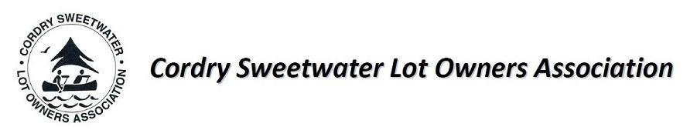
August 22nd, 2024

I. Pledge of Allegiance – took place at 7:02

II. Call to Order – The meeting was called to order by President Alison Randolph at 7:02

III. Those members in attendance: Alison Randolph, Linda Morgan, Angie Von Hoven, Jeff Romick, Dale Sears, and Kathy Wood

Absence: Felicia Velez

IV. June, July, and Annual Meeting minutes- Highlights were shared, but all minutes are posted on the website. Minutes were approved by Kathy Wood and seconded by Angie Von Hoven.

V. Freeholder Concerns – There were no freeholder concerns

VI. Treasurer’s Report - Angie Von Hoven reviewed the treasurer’s report. A detailed report is attached. The report was approved by Kathy Wood and seconded by Linda Morgan

VII. Reports:

- Clubhouse- Cassie – report consisted of all that was done to the clubhouse this year, which was reported in the annual meeting.
- Roads- Eric Von Hoven – Report covered the paving of the streets in Cordry-Sweetwater.
- Building-Kathy Wood shared the building and repairing of docks approved on Cordry/Sweetwater, with three dredging applications approved.
- Water– Jeff Romick is the commission member for water
- Ecology- Brenda Maulden – was sent and on the website.
- Security- Bryan addressed this at our annual meeting.
Angie Von Hoven motioned to approve the commission reports, and Jeff Romick seconded the motion.

VIII. Committee Reports
A) Membership—Linda Morgan—This report was shared at our annual meeting and is on the website.
B) Library- Jo states that the book "All That She Carried" will be available at both the Nashville and Cordray/Sweetwater libraries. Yoga classes will be held from September 4th to October 9th from 9:00 am-10:00 am at the Nashville Library. The classes are limited to 15 participants, so you must register. A cooking contest will be held on September 13th at the Nashville Library at 5:30 pm. If you are interested, you must form a team and sign up. Family movie night at the Nashville library will be on September 9th from 4:30 to 7:00 pm.
C) CSCD—Alison Randolph shared that the topics addressed during the CSCD meeting included the weight of boats vs. lengths. Cordry Dam and Sweetwater Dam will probably be two years away. There is NO smoking at the Sweetwater beach.
D) Merchandise- Felicia reported that the merchandise had been ordered for the block party.
Angie Von Hoven motioned to accept the committee minutes, and Jeff Romick seconded.

IX. Unfinished Business

A) New Commission appointments approved on Aug.20 CSCD Meeting- Jeff Romick and Carrie Vavul
B) Municipal Website—Judy and Alison are updating the website, which is much more user-friendly. We are using the same website company as the CSCD.
C) Newsletter update – Finished and going in the mail.
E) Membership drive: The board has our request to include the cost of CSLOA membership in our water bills. Alison hopes to have information soon.
F) Clubhouse increase for 2025- We discussed the possibility of allowing non-members in the community to use our facilities. What should the pricing be? Remember that we can only increase the membership fees in May, as stated in the Bylaws. The last time fees were raised was in 2006. We asked what the new fees should be. Alison will research this further, aiming to include it in the February newsletter.
G) Updated CSLOA information sheet and Fire Safety Manual – Kathy Wood is updating these.
H) Clubhouse improvements 2024/2025- We want to review the kitchen items to remove anything unnecessary and consider selling them. Dale Sears will investigate this further. We should also take down the BINGO boards and sell them. (Cassie will start cleaning up the Fry Room soon.)

X. New Business

A) Block Party- Chair: Linda Morgan will be leading this activity on September 21, 2024.
B) Pumpkin Carving—Chair: Kathy Wood is chairing the event scheduled for October 19, from 2 to 4 p.m. We are currently seeking a sponsor for this activity. CSLOA provides set-up with tables, snacks, and carving materials.
C) Santa Shop—Cochairs: Felicia and Diane Poff are chairing this event, which will be held on December 7th from 2 to 4 p.m.
D) Alison is working on a volunteer sheet for all these events
E) Signs for September- Working on getting signs for the following events:
- Meeting date for both CSCD and CSLOA,
- Block Party at the BEACH- 9/21 at 6 PM,
- Watch for a new website coming soon!!
- Renew your membership in the newsletter!

XII. Adjournment- Motion was made by Angie Von Hoven and seconded by Kathy Wood.
The next meeting is September 26 at 7 PM.

